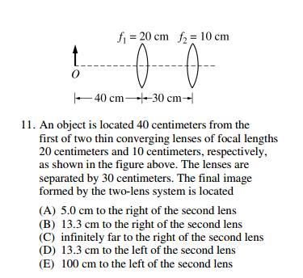

1/i(1)=1/20-1/40=1/40. i(1) is 40 cm to right of first lens. Therefore o(2)=-10.

1/i(2)=1/10-1/(-10). i(2)=5cm

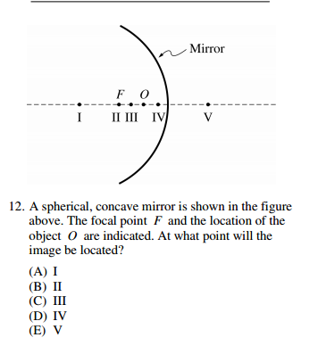

Answer E. The object is inside the focal length. The mirror can not bend light sufficiently to produce a real image. You could solve for “i” with o=f/2 and check.

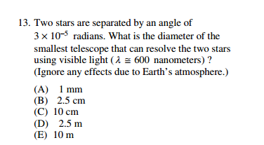

Rayleigh Criterion for diffraction resolution.

3E-5=1.22x 600nm/D get answer B

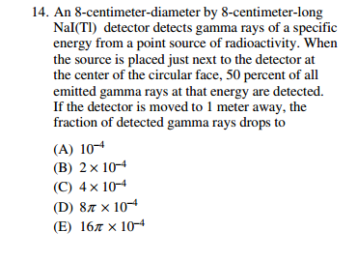

PI*0.04^2/(4PI* 1^2)

Answer C

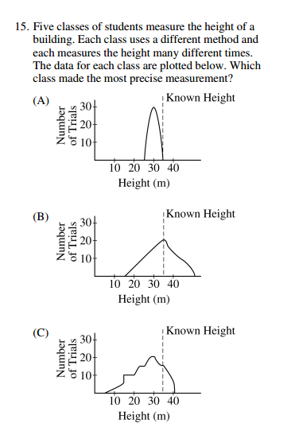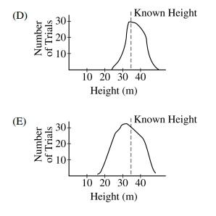
Answer A. Precision is how tight the result is---not how “accurate”---not how close to the best value. Tightest grouping of data, smallest uncertainty.

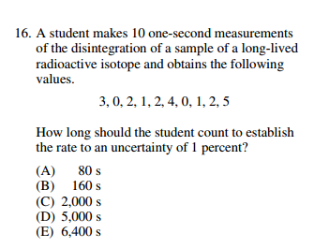
Relative uncertainty is
Sqrt(N)/N=0.01 given

Immediately we need N=10,000

Given 2 counts per second as the average. Answer D

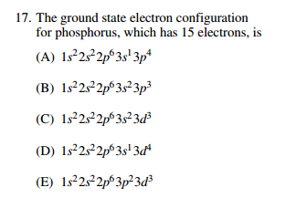

.I lifted the following. Orbitals fill up on this chart by drawing arrows from lower right to upper left diagonally. Answer B
4s 4p 4d 4f
3s 3p 3d
2s 2p
1s

potentialwell's rule of thumb works, but you need to read the order if you go diagonally from the bottom right to the top left.
So you first go:
1s.
2s.
2p 3s
3p 4s
3d 4p 5s
etc.

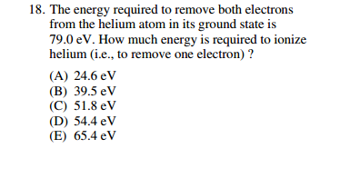

Consider how much energy it takes to remove the second electron. It is then hydrogen like with Z=2.

So E=Z^2*13.6/n^2

Where the electron is removed from the n=1 state.

So E(2)=~54.4

Remaining energy went to first electron. 79-54.4=24.6 Answer A

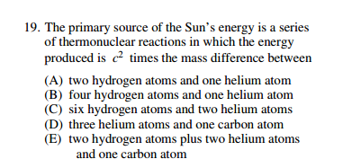

Four hydrogen to on helium. B

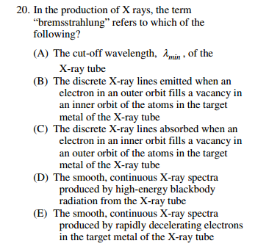

Braking radiation. E---deceleration.

